Module 3
1).What is RDBMS
Ans.RDBMS stands for Relational Database Management System.All modern database management systems like SQL, MS SQL Server, IBM DB2, ORACLE, My-SQL, and Microsoft Access are based on RDBMS.It is called Relational Database Management System (RDBMS) because it is based on the relational model introduced by E.F. Codd.
2).What is SQL.
Ans.SQL is Structured Query Language, which is a computer language forstoring, manipulating and retrieving data stored in relational database.SQL is the standard language for Relation Database System. All relational database management systems like MySQL, MS Access, Oracle, Sybase, Informix, postgres and SQL Server use SQL as standard database language.
3). Write SQL Commands.
Ans. DDL – Data Definition Language
⚫ DML – Data Manipulation Language
⚫ DCL – Data Control Language
⚫ DQL – Data Query Language
4). What is join?
Ans.SQL Join statement is used to combine data or rows from two or more tables based on a common field between them.
5). Write type of joins.
Ans.⚫ INNER JOIN: returns rows when there is a match in both tables.
⚫ LEFT JOIN: returns all rows from the left table, even if there are nomatches in the right table.
⚫ RIGHT JOIN: returns all rows from the right table, even if there are no matches in the left table.
⚫ FULL JOIN: returns rows when there is a match in one of the tables.
6).How Many constraint and describes it self.
Ans.Constraints are the rules that we can apply on the type of data in a table. That is, we can specify the limit on the type of data that can be stored in a particular column in a table using constraints.
The available constraints in SQL are:
- NOT NULL: This constraint tells that we cannot store a null value in a column. That is, if a column is specified as NOT NULL then we will not be able to store null in this particular column any more.
- UNIQUE: This constraint when specified with a column, tells that all the values in the column must be unique. That is, the values in any row of a column must not be repeated.
- PRIMARY KEY: A primary key is a field which can uniquely identify each row in a table. And this constraint is used to specify a field in a table as primary key.
- FOREIGN KEY: A Foreign key is a field which can uniquely identify each row in a another table. And this constraint is used to specify a field as Foreign key.
- CHECK: This constraint helps to validate the values of a column to meet a particular condition. That is, it helps to ensure that the value stored in a column meets a specific condition.
- DEFAULT: This constraint specifies a default value for the column when no value is specified by the user.
7). Difference between RDBMS vs DBMS.
Ans
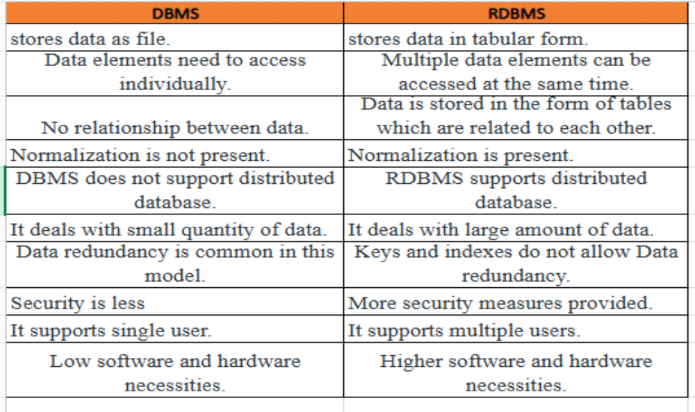
8). What is API Testing.
Ans.Application Programming Interface (API) is a software interface that allows two applications to interact with each other without any user intervention.
9). Types of API Testing.
Ans.There are mainly 3 types of API Testing
⚫ Open APIs: These types of APIs are publicly available to use like OAuth APIs from Google. It has also not given any restriction to use them. So, they are also known as Public APIs.
⚫ Partner APIs: Specific rights or licenses to access this type of API because they are not available to the public.
⚫ Internal APIs: Internal or private. These APIs are developed by companies to use in their internal systems. It helps you to enhance the productivity of your teams.
10). What is Responsive Testing?.
Ans.A responsive web design involves creating a flexible web page that is accessible from any device, starting from a mobile phone to a tablet.
- Furthermore, a responsive web design improves users’ browsing experience.
- Considering this from a quality assurance perspective, a responsive web design requires thorough evaluation using a variety of devices before it is ready to go live.
- Software testers may find it challenging to perform responsive design testing as a variety of factors are to be looked into during the testing phase.
- Some points to be understand for Responsive Testing.
- The challenges involved in testing a responsive website
- How website testing differs from a mobile device to a computer
- Rules and guidelines to be followed during responsive design testing and
- Lastly, various tools available to perform responsive testing
11). Which types of tools are available for Responsive Testing.
- LT Browser
- Lembda Testing
- Google Resizer
- I am responsive
- Pixel tuner
12). What is the full form of .ipa, .apk.
Ans.APK file stands for (Android Application Package). APK is a file extension of an Android device. APK files can normally be used in Android and a number of other Android-based Operating Systems for the distribution and installation of mobile apps and mobile games.
An IPA (iOS App Store Package) file is an iOS application archive file that stores an iOS app. Each IPA file includes a binary and can only be installed on an iOS device.
13). How to create step for to open the developer option mode ON?
Ans.To open developer mode in mobile
Navigate to Settings > About phone.
Scroll down until you locate the Build number section.
Tap the Build number until you see a message that says You are now a developer.
Enter your PIN number.
The Developer options will be activated; you can now access it at the very bottom of the main Settings menu.

